Wireless Lock SDK Final Assembly

Project Overview
The purpose of this project is to implement an SDK for a locking system designed to secure a variety of doors in different applications from office buildings to commercial stores and government offices. The locking system consists of host software, a number of locks, a portable programmer and a wireless gateway (required for the wireless locks option). Depending on customer requirements and budget constraints the system can be used in an offline mode or a wireless mode with a quasi real-time data connection back to the host software.

The locking system has an open architecture program that is designed to provide information and sample code to third party customers that want to interface their applications to control and interact with said locking system (thus their software becomes the host software). The program is governed by 3 existing interface control documents that define the protocols used to communicate to each device.

This project focuses on creating an SDK to enable a third party to communicate to the locking system via the WAP from a software based application (the host software).

The lock system as defined currently works by sending commands from host software down to a lock via the ORP protocol. The communication packets/commands are routed as follows:
Host Software (LMS) ---> Wireless Access Point --> Lock Radio (WLM) ---> Lock
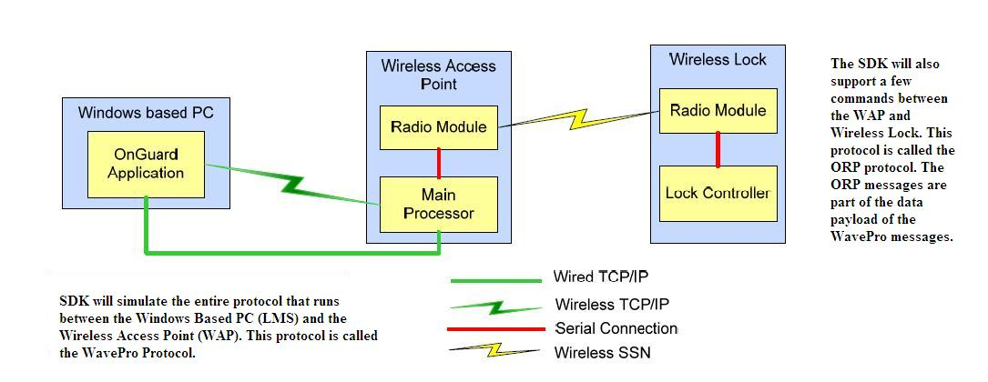

In the diagram above, the ORP client is the WAP radio module and the ORP server is the Wireless Lock Radio Module. The WavePro client is the Windows Based PC (LMS) and WavePro server is the Wireless Access Point Main Processor.

The ORP protocol is defined in the ORP_OA.pdf document and the WavePro protocol is defined in the ICD_WavePro_OA.pdf in the Open Architecture SDK folder.

The ORP commands are themselves embedded in WavePro commands. The basic flow is as follows:

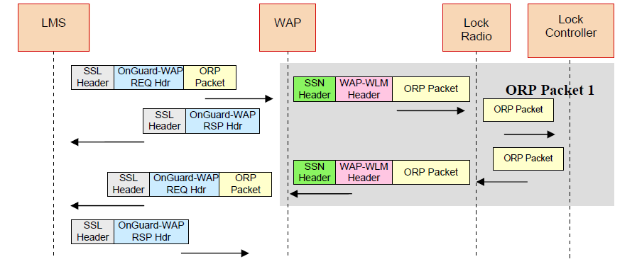

Note – The ORP protocol is implemented over SSN (a proprietary protocol) but in this project it will be implemented over TCP.

Requirements

This assembly will integrate the Wireless Lock SDK WavePro component with the Wireless Lock SDK ORP component. The point of integration is the call from the WaveProServer to the ORPClient.

Setup SSL for the TCP communications. See section 6 of SDS for details. The network data for both protocols will be encrypted using SSL.

Setup the locking plan. A CSV file with valid locking plan will be provided by the client and will be available at installation time. The assembly will read the CSV file according to section 2.1 and 3.0 in the ICD_PP_OA.pdf. The data read from the locking plan will be stored in structures that hold locking plan information and will be used for the mock data at the ORP server side.

This assembly will use the tests of both components and combine them to form end-to-end tests. It will also provide contain reference implementations and typical scenarios (demos). An example reference implementation for the LOCK command could be as follows:

A description of the installation procedure

Test open door with invalid user

See that it doesn’t open (error returned)

Test open door with valid user

Lock opens

One reference implementation should be provided for all the 6 ORP commands covered by the SDK.

This assembly will generate documentation for the SDK as well as some sample codes. Documentation should be like developer manual. It should describe how customers can use this SDK and write programs around the API.

Submission Deliverables

Provide a C# project of the entire SDK

A deployment guide explaining the steps on how to setup and verify the project.

Technology Overview

Application Technologies
- C# 3.5
- TCP/IP
- SSL

Project Dependencies

Components
- Wireless Lock SDK WavePro 1.0 C# Custom Component
- Wireless Lock SDK ORP 1.0 C# Custom Component

Third Party Libraries
- Log4Net

Project Deliverable Details

Source code setup
- styx.wireless.lock.wavepro.entities
- styx.wireless.lock.wavepro
- styx.wireless.lock.orp.entities
- styx.wireless.lock.orp

Build Setup
MSBuild based setup to build and deploy the system.

Final Submission

- For each member, the final submission should be uploaded to the Online Review Tool.
- The final submission will be reviewed using the standard Online Review Assembly Scorecard.

